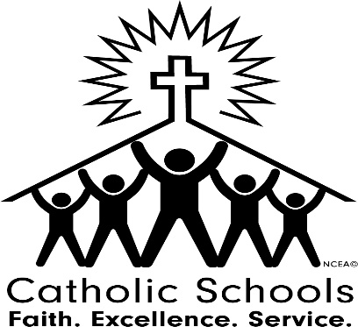
St. John Paul II Regional School

January 30, 2022 – Sunday
Catholic Schools Week begins! Students are encouraged to attend Mass wearing their school uniform. Please send us a pic and thank a parishioner for their support! Students will hand out prayer cards after the Masses.

January 31, 2022- Monday
Show your support for our St. Vincent DePaul Food Pantry. Students and staff may dress down if the bring an item from the list we have published. Fr. Rene will speak to grades 3-8 about vocations.

February 1, 2022—Tuesday
Students may wear their spirit wear or day of service shirts with jeans or school sweatpants. Students will get an extra recess outside. Schoolwide Bingo in the afternoon.

February 2, 2022—Wednesday
Students will celebrate our Nation with a prayer service outside as we start our day! We will pray the rosary as a school for our nation at 1:30 PM, and we will live stream it. Students may wear red, white and blue as we celebrate our nation.

February 3, 2022—Thursday
Students in grades 3-8 will celebrate Vocations with virtual guest speakers.

February 4, 2022—Friday
First Friday Mass at 9 AM. Students will celebrate Faculty and Staff with special treats. Dismissal is at 1 PM.

February 5, 2022—Saturday
We celebrate our families, email a picture of your family to bcimorelli@jp2rs.org for our social media posts that day!

